
6.1 Dashboard design (Dummy) - Evidence 3 (Individual)
Data Analytics and Artificial Intelligence Tools 2 (Gpo 101)

Team: Le Frites

Names and IDs:

Humberto Gonzalez Escamilla - A00837328

November 17, 2025
1. Problem context
Whirlpool manages hundreds of products across multiple trade partners such as Liverpool, Coppel, Elektra, Walmart, and others; each SKU behaves differently depending on the retail partner, seasonality, inventory levels, applied discounts, and historical demand.
Sales and pricing managers face a recurring challenge:

“What price should I set for the next weeks for this product at this specific partner, and how much can I expect to sell?”

This decision relied heavily on manual analysis and personal experience; however, weekly performance varies sharply due to seasonal effects, promotional windows, inventory availability, and different pricing strategies across partners.
To support better decisions, the dashboard combines:
- Historical SKU - TP insights
- Weekly ML predictions for final price and quantity
- Visualization of historical context for the selected week
- Exploration of scenarios using discounts and week of the year

The goal is to give Whirlpool sales/pricing managers a unified, fast, interactive tool that helps them design weekly pricing strategies with clear visibility of the product’s past and predicted behavior.

2. User persona
Sales and Pricing manager (Primary user)
A Sales/Price manager at Whirlpool is responsible for:
- Negotiating weekly price updates with key trade partners
- Reviewing SKU performance and understanding the seasonal demand
- Evaluating promotional windows and discount sensitivity
- Ensuring competitive pricing without harming revenue or margins
Pain points:
- Manual Excel analysis, often fragmented and slow
- Difficulty understanding the weekly specific behavior
- No fast way to test “What if we change the discount?”
- Need to justify price recommendations to partners

The dashboard solves these pain points by centralizing data and predictions in one place.

3. Impact of data-driven decisions
By using this dashboard:
- Pricing decisions become weekly, precise, and data-backed
- Predictions provide a baseline for expected performance
- Historical insights prevent blind trust in ML models
- Discount changes can be simulated instantly
- Sales managers can support negotiation with clear graphs and historical trends
This reduces uncertainty, increases negotiation confidence, and improves alignment between pricing strategies and real customer demand.


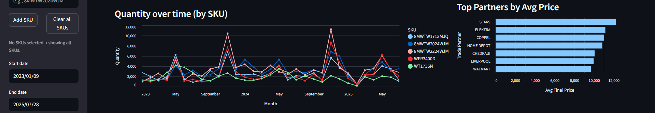
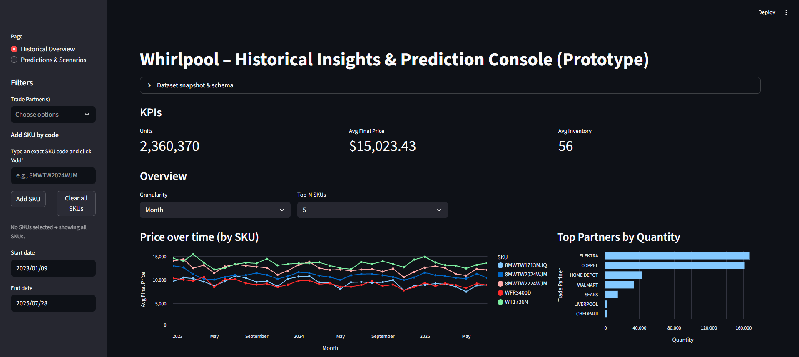
4. Dashboard visual design


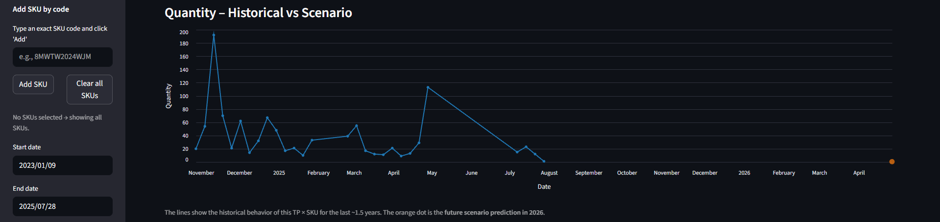
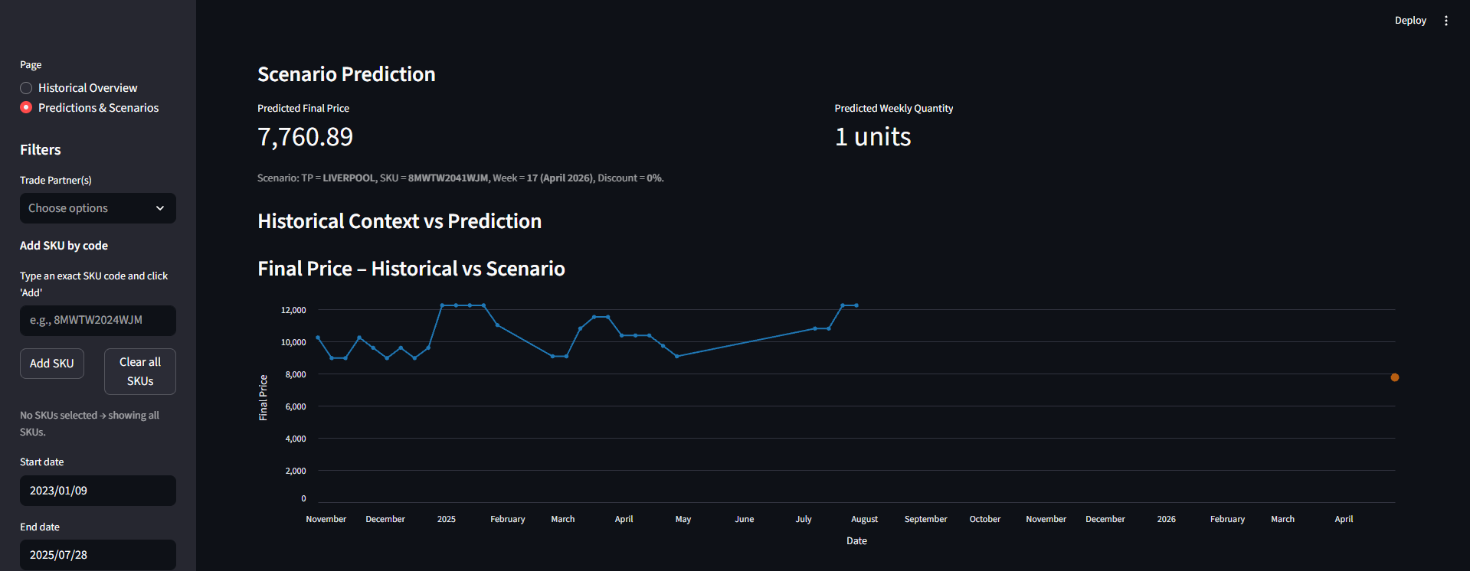
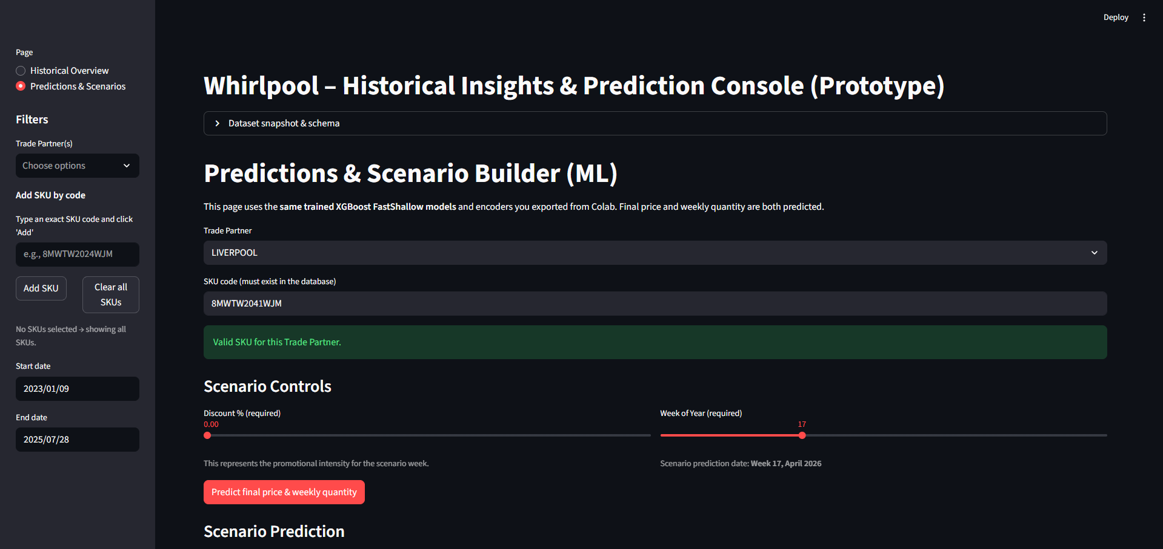
4.1 Main sections and panels
Page 1 - Historical overview
Sections included:
- Dataset Snapshot and Schema
- Global sidebar filters
- KPI banner
- Granularity and chart controls
- Time series (price and quantity)
- Partner comparisons

This page focuses on discovery and understanding, letting the user explore SKU - TP combinations and identify patterns.

Page 2 - Predictions and scenarios
Sections included:
- SKU and Trade Partner selectors
- Week-of-Year selector
- Discount selector
- Instant ML prediction of:
  - Final Price (weekly)
  - Quantity (weekly)
- Historical context preview for the selected week

This page focuses on decision-making, allowing the user to test scenarios and see expected outcomes.

4.2 Page layout explanation
Historical overview layout
- Left side shows filters and data exploration options
- Center section shows KPIs and time series charts
- Right section shows bar charts comparing partners
- Colors are used consistently by SKU to avoid confusion
- Altair charts allow hovering tooltips and interactivity
This layout allows fast SKU-switching without losing context.

Prediction Page Layout
- Clean interface: only the essential controls
- The page does not show the historical filters
- It displays only:
  - SKU selector
  - TP selector
  - Week selector
  - Discount selector
Below the prediction cards:
- A small set of historical charts helps verify if predictions seem realistic
- If the ML model suggests an unusual price or quantity, the user can visually compare it against last year’s trend
This prevents overreliance on the ML model.

4.3 Use of color, placement, and interactivity
- Blue/orange/green distinguish different SKUs in time-series
- Bar charts sort values automatically
- Hover tooltips reveal exact values
- Calendar only allows Mondays since all weekly data occurs on Mondays
- Granularity selector modifies data aggregation without affecting KPIs
- Top-N selector filters the charts without changing any other page elements
This interactivity provides exploration while preserving consistent logic.

5. Dashboard walkthrough (user narrative)
“The sales manager begins by selecting the product and trading partner using the sidebar filters…”
- The dashboard opens on the Historical Overview page.
They first see a dataset snapshot and summary metrics that provide context about the available data.
- Using the left sidebar, they select:
  - One or more trade partners
  - Any SKU codes they want (typed manually)
  - A date range
- The KPI section updates instantly, showing:
  - Total units sold
  - Average final price
  - Average inventory
- The manager then scrolls to the charts to explore:
  - Price over time
  - Quantity over time
  - How discounts historically affected demand
  - Top trade partners by quantity or price
- To analyze specific weeks, the manager switches granularity to “Week,” chooses a window of up to 12 weeks, and the dashboard updates accordingly.
- Once they find a SKU - TP combination worth analyzing, they move to the Predictions page.

6. ML results and explanation
On the Predictions page, the user sees:
Controls influencing the model
- SKU
- Trade Partner
- Week of Year
- Discount to simulate
The ML uses:
- XGBoost FastShallow model for PRICE
- XGBoost FastShallow model for QTY
Both models were trained using:
- Weekly engineered features
- Lagged values
- Rolling means
- Seasonal patterns (sin/cos of week of year)
- Encoded SKU and TP identifiers

6.1 Price model performance (good)
- RMSE ≈ 1,823
- MAE ≈ 740
- R² ≈ 0.985
- CV_RMSE ≈ 1,323
- MAPE ≈ 4.1%
Interpretation:
This model predicts weekly final prices with high accuracy.
It captures seasonality and specific price patterns for each partner.

6.2 Quantity model performance (moderate to weak)
- RMSE ≈ 82
- MAE ≈ 34
- R² ≈ 0.41
- CV_RMSE ≈ 76
- MAPE extremely high (due to many zero QTY weeks)
Interpretation:
The quantity model is useful as a directional signal (higher/lower demand),
but its absolute values should not be interpreted blindly.
Zero inflated demand and noisy sales patterns limit accuracy.

6.3 Human in the loop design
The dashboard deliberately shows:
- Historical pricing
- Historical demand
- Seasonal context for the selected week
so that the user can validate:
- Whether the ML prediction makes sense
- Whether discount changes historically increased demand
- Whether the SKU behaves differently with certain partners
This ensures the model is a support tool, not a replacement for expertise.

7. Sample use case
“How a Pricing Manager uses the dashboard to recommend a weekly price”
Maria, a Whirlpool pricing manager, wants to set the price for the “8MWTW2024WJM” washer at Liverpool for Week 34 of the upcoming year.
Step 1 - Explore the SKU historically
She types the SKU code into the sidebar and selects Liverpool.
The dashboard now shows:
- Average final price: $6,200 MXN
- Quantity trend showing a seasonal peak around Weeks 30–36
- Partner comparison charts confirming Liverpool is one of the top sellers for this SKU

Step 2 - Move to Prediction Page
She goes to the “Predictions & Scenarios” page.

Step 3 - Build the scenario
She sets:
- Week = 34
- Discount = 10%
The model returns:
- Predicted final price: $5,890
- Predicted weekly quantity: 13 units

Step 4 - Validate with historical context
A time-series chart appears below the prediction, showing:
- Historical prices during Weeks 30-36 in 2023-2024
- Quantity patterns from previous years
- A visible peak in demand for this product during summer
The historical curve shows that selling price usually drops slightly during Week 34 due to high competition.
The ML prediction aligns with this trend.

Step 5 - Make a decision
Maria decides:
- The suggested price seems reasonable
- Quantity prediction is close to last year’s observed values
- There is no abnormal prediction of spike or drop
She documents the recommended price and proceeds to negotiate with the trade partner.

8. Conclusion
This dashboard integrates:
- Historical insights
- Machine learning predictions
- Seasonal context
- Partner behavior
- Interactivity and scenario building
It enables Whirlpool’s pricing/sales managers to:
- Make fast, data-driven recommendations
- Validate ML predictions using historical evidence
- Test discount scenarios on demand
- Navigate complex SKU - TP behavior clearly and efficiently
It supports human decision making, ensuring both quantitative predictions and qualitative judgment work together to define optimal weekly prices.

